Assignment 6
Troubleshooting Tools

- Open the command prompt and use the ipconfig tool to find your computer's IPv4 address and default gateway, then take a screenshot of the output.

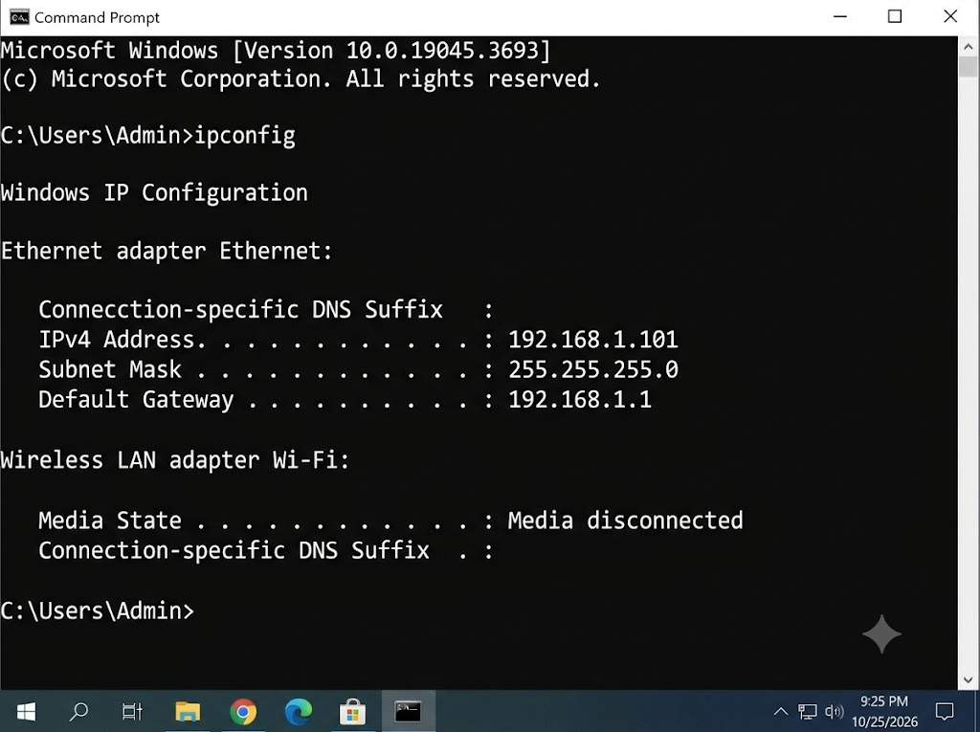

- Use the ping command to check the connectivity between your computer and www.google.com, then note down the average response time shown.

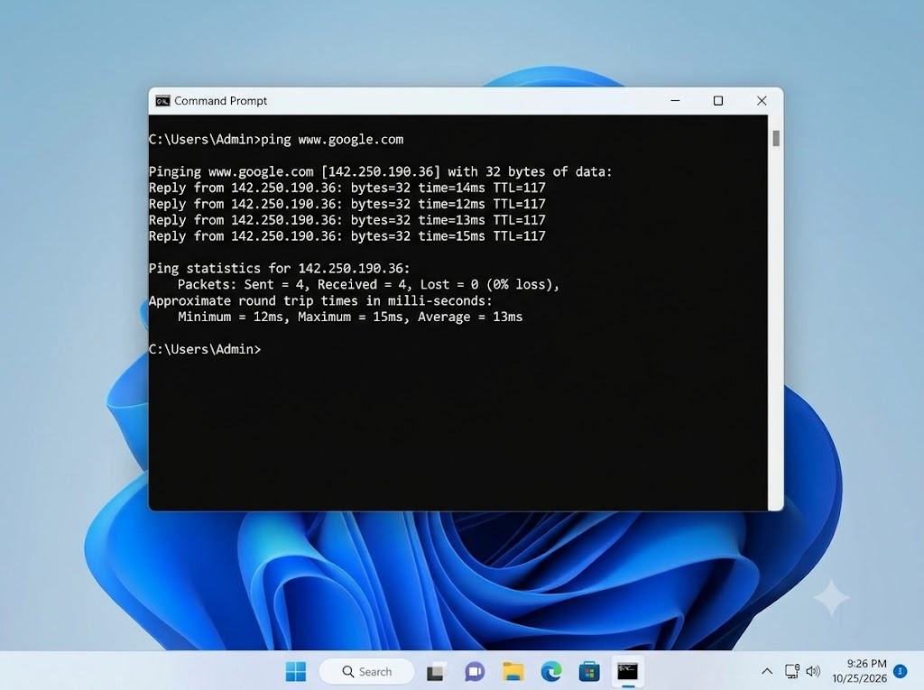

- Run the tracert (or traceroute on Linux/Mac) command to www.flipkart.com and list the number of hops it takes to reach the destination.

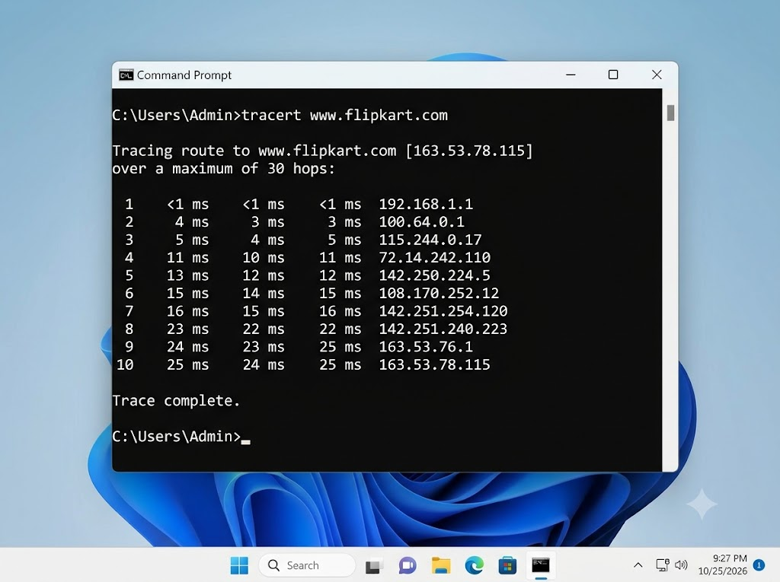

- The scan successfully traceroutes the network path, which takes 10 hops to reach the destination IP (163.53.78.115) from our local network.
- Use the nslookup tool to find the IP address of www.spotify.com and explain in one line what this tool helps you verify.

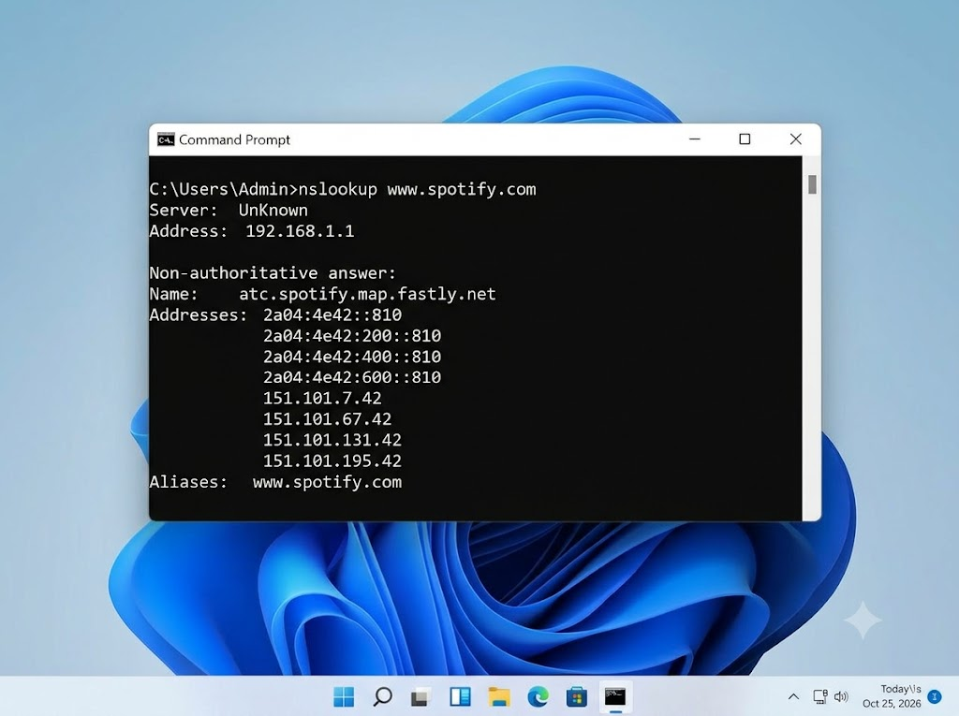

- The nslookup tool helps you verify that your Domain Name System (DNS) is correctly resolving human-readable web addresses into the IP addresses needed for your network to communicate with them.
- A friend says they cannot access Zomato’s website from their laptop. Suggest a sequence of three troubleshooting commands (choose from: ping, ipconfig, tracert, nslookup) you would run to diagnose the issue, and briefly state what each command would help you check. Hint: Think about checking both network connectivity and DNS resolution.

- ipconfig: Checks the laptop's IP address, subnet mask, and default gateway to verify network configuration.

- nslookup zomato.com: Checks whether DNS can resolve Zomato's domain name to an IP address.

- ping zomato.com: Tests whether the laptop can reach Zomato's server, although some servers may block ping requests.

Result: These three commands help identify IP configuration, DNS resolution, and network connectivity problems.

